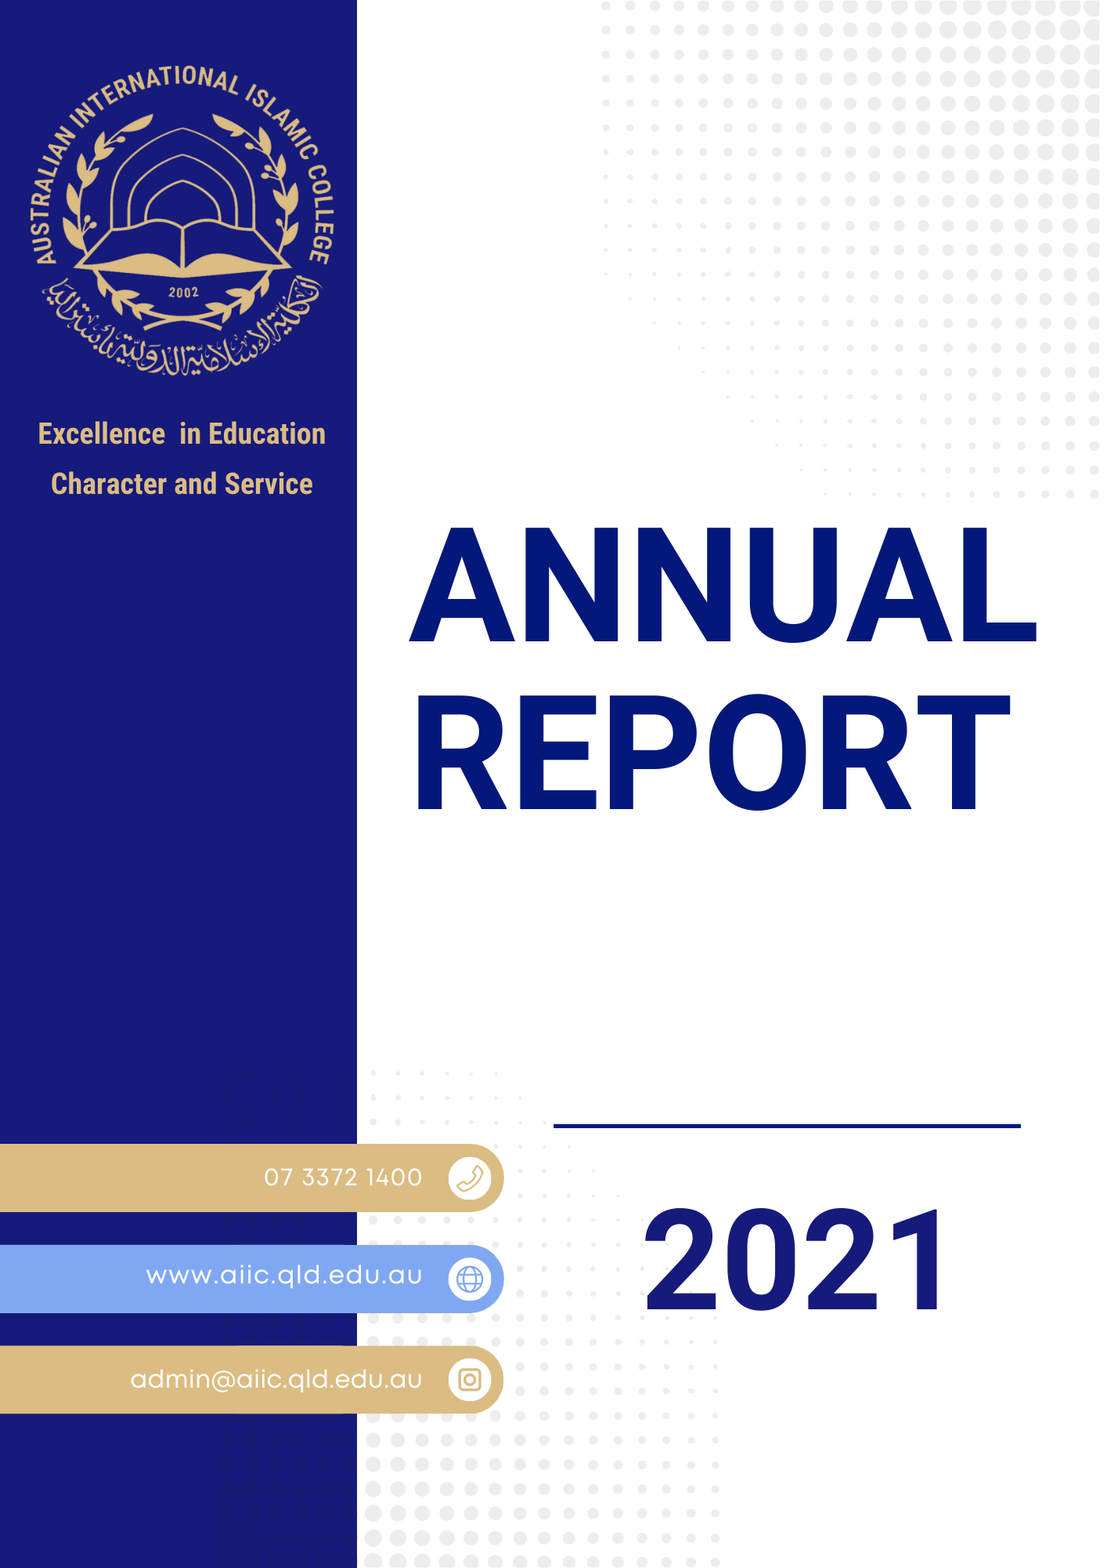

Founders Message

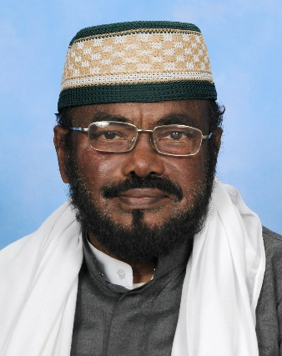
Assalamu Alaikum Warahmatullahi Wabarakatuhu

It gives me a great pleasure to congratulate AIIC community for the successful completion of 2021.

The pandemic was still with us but our experience in 2020 resourced us to confront lockdowns in 2021.

AIIC deployed use of social media and TASS to communicate with parents.
AIIC has launched AIIC App providing information to students, parents and to key stake holders of the AIIC community.

For primary students’ new laptops and tablets were purchased and for secondary students BYOD (Bring Your Own Device) was introduced resulting in improved care.

The Federal Government has implemented a new funding model for all independent schools based on the capacity of parents to contribute to school fees determined by the taxable data. Under the new funding model AIIC will sustain material reduction on Australian Government funding in the period 2022 – 2029.

We are very pleased to see completion of the third classroom building at the Durack Campus. This new building has six (6) GLAs. This building has also provided us additional space to accommodate increasing administrative and support staff to serve all AIIC campuses.

I am very pleased to report the results of survey conducted in 2021 seeking feedback from teachers and parents.
The most pleasing conclusion from the survey was:
- AIIC’s greatest strength lies in nurturing Islamic values, followed by curriculum related excursions.
- Parents have also expressed their satisfaction with AIIC administration including communication between parents, students’ teachers and administrative staff.

I would like to register my congratulations to all AIIC staff for their professionalism during the COVID-19 year 2021. I would also like to say a big thankyou to our students and their parents for their efforts and cooperation during these challenging times.

May Allah bless you all.

Sheikh Abdul Quddoos Al Azhari
The National Grand Mufti of Australia

Founder of Australian International Islamic College (Brisbane Muslim School),
Darul Uloom Islamic Academy
Al Qalam Educational Trust Chennai,
Justice of Peace for Australian Government
Authorised Marriage Celebrant by Australian Government
M.A. (History, Culture and Civilization) Al Azhar Cairo, Grad Dip Education – Darwin, Australia,
ESL Massey University - New Zealand
Australian Medal by Queen Elizabeth UK & Prime Minister of Australia

AUSTRALIAN INTERNATIONAL ISLAMIC COLLEGE

2021 REPORT

Twenty Years Serving the Muslim Community

From the first gathering of key stakeholders of the Muslim community at the opening ceremony of the Muslim school at Buranda, the collective desire for establishing Islamic schooling in Brisbane QLD was revealed, with a humble beginning of 22 enrolments in 2002.

The Australian International Islamic College is now educating over 1253 students across five campuses in 2022. The following are the enrolments reported in August 2021.

AIIC – Durack Main Campus
AIIC – Gold Coast Campus
AIIC – City Campus
AIIC - Logan Campus

TOTAL

In terms of permanent purpose-built buildings, AIIC Durack Main Campus has six primary classrooms buildings and one secondary building plus STEM building. The STEM building supports an ICT, Engineering, and Robotics curriculum delivery and the Durack Campus has also a huge multipurpose hall with the capacity to service more than 1000 guests.

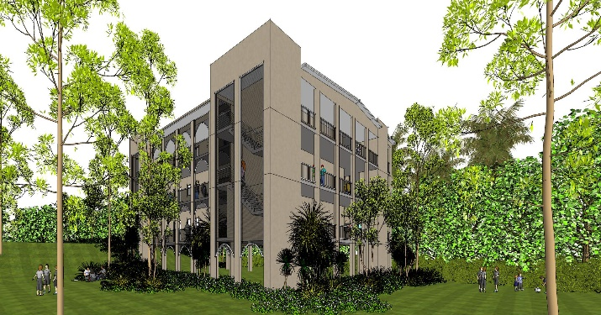
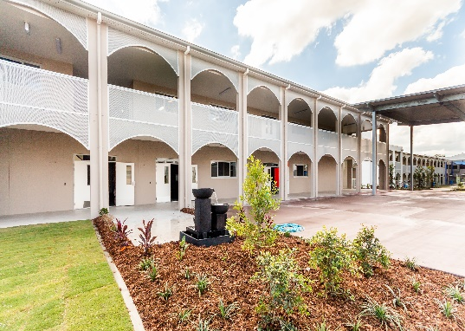
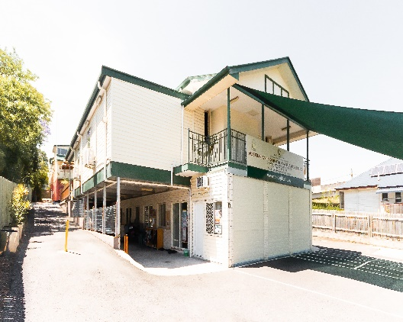
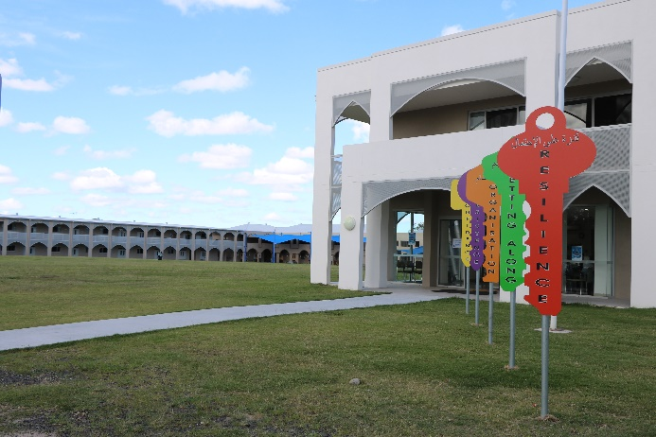
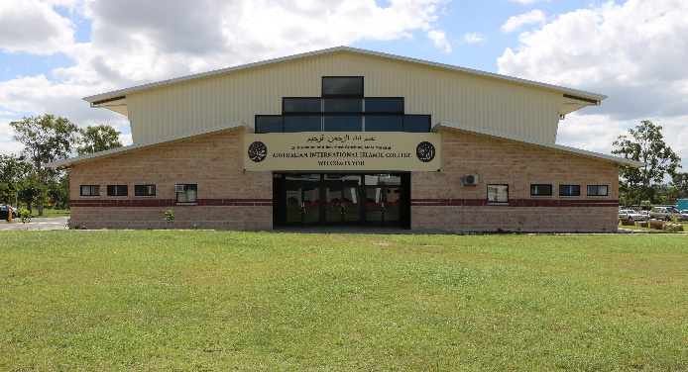
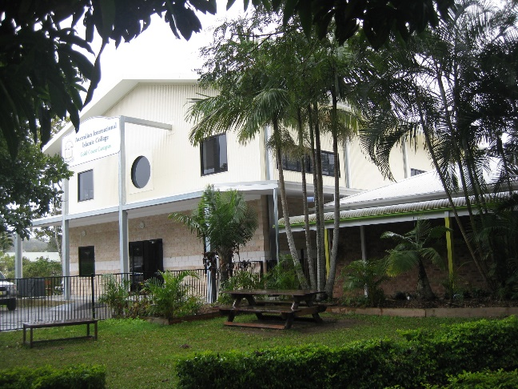

Growth of Enrolment 2020 - 2021

It was encouraging to see a significant enrolment growth during the last two COVID affected years.
AIIC Durack campus and Gold Coast campuses registered growth in enrolment in excess of 12%, against the loss of enrolments that occurred in many other private schools during the two COVID years of 2021 – 2022.

The Durack Campus recorded the largest increase in student numbers in five years.

The satellite campuses currently operate using temporary demountable buildings which can create hesitancy in the minds of parents to bring their children to enrol in Islamic faith-based colleges. A permanent primary classroom building at the Gold Coast is planned to be completed by the end of 2022 providing impetus to Muslim parents to enrol their children in the AIIC Gold Coast campus.

The first batch of Graduates under the newly implemented Queensland Certificate of Education which has replaced OP with ATAR (Australian Tertiary Admission Rank) are entering tertiary education in 2022.

The Certificate of Education and Australian Tertiary Admission Rank was implemented for Year 11 in 2019, who have now completed year 12 schooling in 2021.

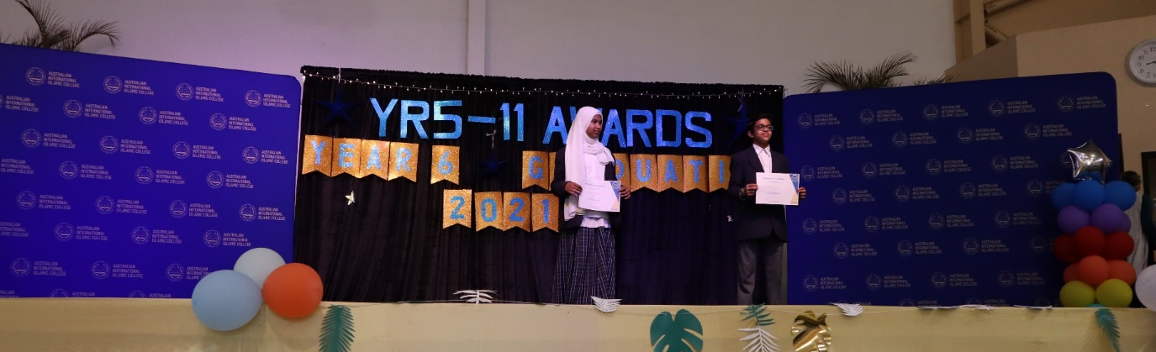

AIIC Philosophy

AIIC is determined to provide an exemplary Islamic faith-based education in a safe and caring environment, acting as an extension of home and promoting a sense of family and community.

AIIC Vision
To establish the Australian International Islamic College with a vision of being the standard bearer of holistic, universal Islamic Education in Australia.

AIIC Mission
To provide unwavering commitment to the delivery of excellence in education and development of good character in our students for the benefit of Australia in particular, and in general to the whole world.

AIIC Values
AIIC campuses aims to develop an environment that is underpinned by Islamic Faith and values of respect and integrity.

The Governing Board guarantees to provide all modern/technical advanced resources necessary to support the delivery of the prescribed curriculum by the Education Department.

Central Leadership Support Staff

The Governing Body has established an excellent leadership team at its main campus at Durack.
With a charter to maintain corporate leadership and development of policies and procedures, it also provides professional management of finances, payroll, legal registration, compliance and accreditation, HR. and allocation of resources for all campuses. The leadership team visits all campuses on a regular basis to ensure adherence to all accreditation requirements and that all teachers and administrative staff undertake professional development regularly and keep abreast with current policies and procedures.

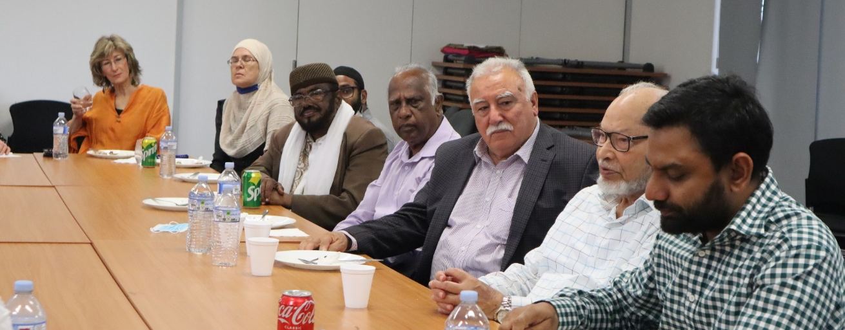

The Leadership Team consists of the following support staff.

- Principal of AIIC
- Coordinators
- Head of Primary
- Head of Secondary
- VET Coordinator
- Wellbeing Officer
- Head of Finance Department (Accountant CPA)
- Administrative Officer
- Facility Manager.

AIIC has implemented TASS (The Alpha School System) as an administrative system, managing data collection and providing timely financial profit/loss, balance sheets and the provision of quality leadership management and administration, improving learning for all students.
The professional development of all staff is conducted at the main campus at Durack to ensure compliance in student protection and behaviour management policies.
Staff are also encouraged to participate in external professional development activities offered by other educational organisations including Independent Schools Queensland (ISQ).

Safety of Staff and Students Under Covid-19

AIIC is committed to ensuring a safe place of work, learning and wellbeing for staff and students.
AIIC is also committed to ensuring this continues to occur during the Covid-19 pandemic.
AIIC has been monitoring the advice provided by the Queensland Government and Queensland Chief Health Officer to ensure staff, students and community members are well supported during challenging in and out of home-based learning.

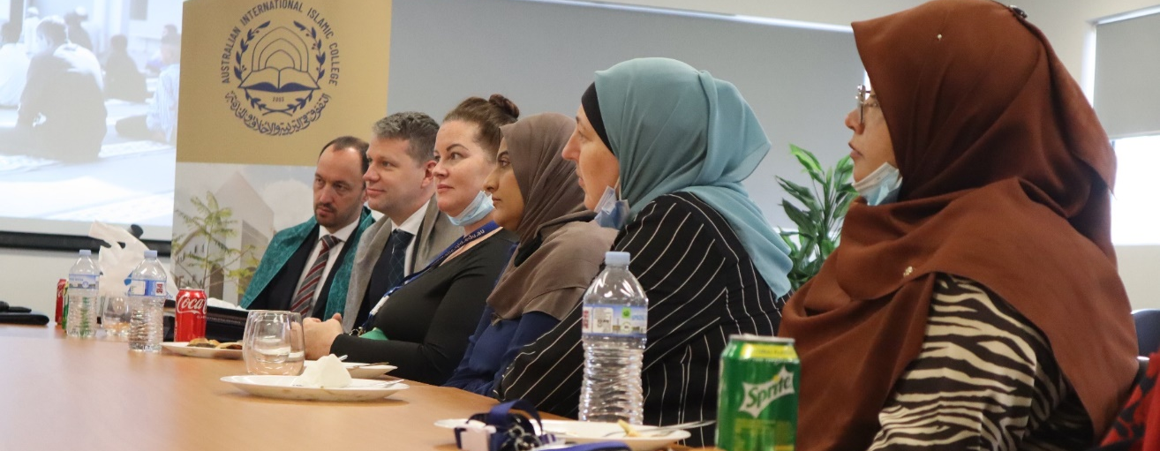

Use of Technology under Covid-19

AIIC deployed the use of social media and TASS (the school administration system) to communicate with parents. AIIC has also launched
- AIIC App
- Facebook page
- Translation of important and critical information into five languages
- Video communication from Principal with Somali interpretation
- Empowering parents to use email and text messages has proved valuable during Covid years.

New laptops and tables were purchased for all primary school students. Students are taught keyboard skills and Bee-bots in Prep and coding using scratch in upper primary. Secondary students have regularly visited QUT to attend STEM workshops promoting STEM learning BYOD (Bring Your Own Device) was introduced during 2021 resulting in improved care of laptops by secondary school students online learning has been implemented.
Literacy Pro, Prime Maths, Reading Eggs programs have been successfully implemented. Jac Plus for secondary – provided text as well as active learning for secondary students proved very successful.

Care for Environment

AIIC students actively engage in the Containers for Change Program and Student Council helps with recycling of paper from classrooms. The gardening club has cultivated garden beds in various parts of the college grounds.

AIIC Security upgrade

During 2021, the roll out of electronic door locking system and CCTV installation across the Durack campus was completed.
New security gates were installed at the front entry door by the Administrations Building.

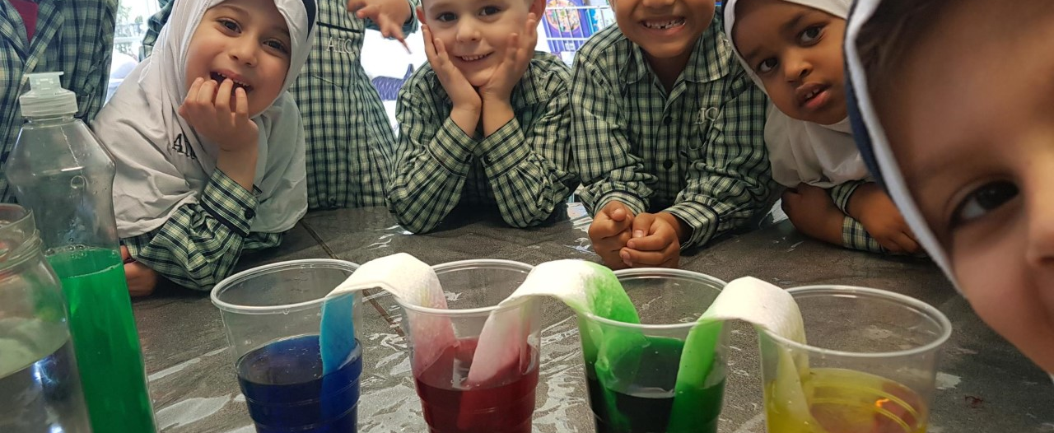

Bush School

The Bush School was established at the Durack Campus in 2020 under the guidance of the executive leadership team, providing a unique opportunity for students to learn about the natural bushland through play, creativity and risk taking. Nature can be daring, and it can be silent. It can be wild or gentle, gloomy, or glorious. Being in nature encourages students to think for themselves, create, imagine, navigate challenges, and build resistance.

When children arrive in the Bush Program, they start observing what they can see around them. This may be mushrooms, native animals, birds, dead trees, and low branches which they may climb. They listen to various sounds including the wind and the birds. The bush school encourages children to learn through doing - to appreciate and be aware of the resources around them.

Bush Schools enhance their love and connection with nature, and this education results in a natural care and respect for the environment.
They develop skills and experience through:
- Stretching eyes to the horizon
- Searching for flying birds
- Working out which way the wind is blowing.
- Getting out of the classroom into the open air and bush improve the sensory systems.
- Learning to balance, rotate, focus and improve reflexes.
- Balancing on a log provides vital developmental feedback for growing and learning.

Bush school provides a natural way of learning outside in the healthy sunshine and fresh air. This encourages learning in a holistic way, in an inclusive and dynamic natural classroom.

Bush school has been regularly used by the lower primary school students largely by Prep, Years 1 and 2 at the Durack Campus.

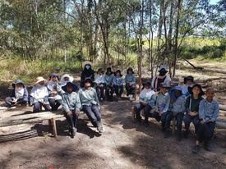
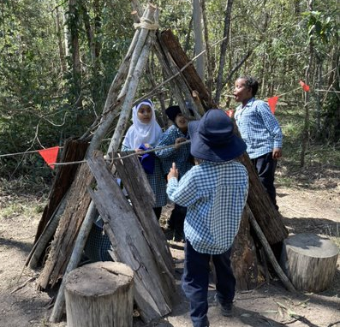

STEM

To enhance the capacity to integrate STEM subjects, AIIC Durack Campus has built a STEM building equipped with a wet lab (Chemistry and Biology), a dry lab (physics and engineering), and a robotics facility (digital technology and computing).

The STEM building is always buzzing with secondary students keen to develop their STEM skills. The hands-on approach to learning in engineering and robotics is very popular. Creating prototype models, working robots, and drones are the talk of our STEM participants. Students have crafted several working robots and constructed several engineering projects, all demonstrating their STEM skills acquired during their stay in the STEM laboratory.

STEM Curriculum

STEM is an approach to learning and development that integrates science, technology, engineering and mathematics. STEM programs/curriculum prepare students to be innovative and creative leaders which is more important now than ever before.

Through STEM students develop key skills including:
- Problem solving
- Creativity
- Critical analysis
- Teamwork
- Independent thinking
- Having initiative
- Communication
- Digital literacy
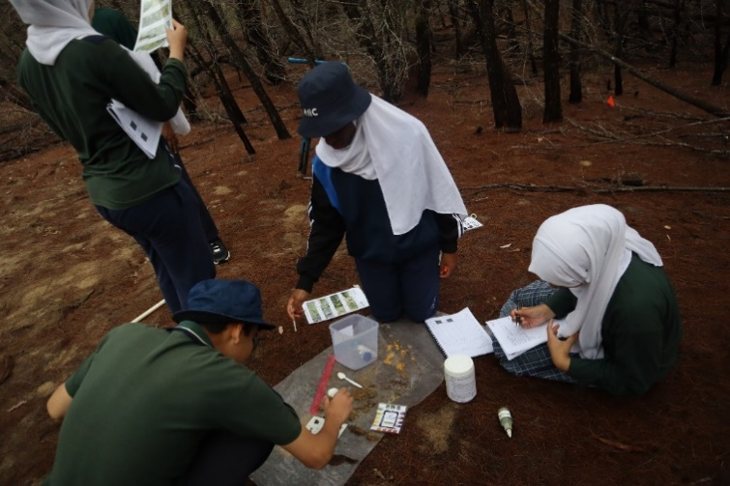
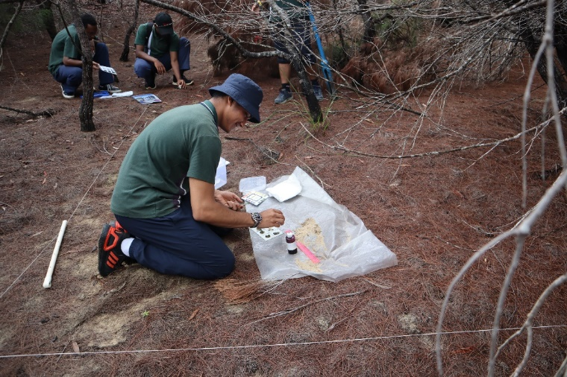

Creating the Love of Reading

The library plays a particularly important role in the life of students by providing opportunities to read books other than their prescribed textbooks.
Students are exposed to the amazing work of local and overseas writers, both fiction and non-fiction. The library fosters a strong love of reading in our students, encouraging their excitement to explore new books and elevating their reading ability and achievement.

Ali Gator and Scholastic Book Fares

The Ali Gator and Scholastics Book Fares were huge hits in 2021 resulting in a large number of sales. The library earned over $3000 worth of points/commissions to spend on even more interesting and educational books for the library.

Perform Education (Education Theatre in Schools)

Perform Education Theatre staged a spectacular show, bringing the Children Book Council Australia’s Shortlisted Books 2021 to life with their hilarious acting skills. Their performance had our students laughing and clapping along for the entire show! The library ran their popular colouring and book design competitions and even put on a quiz. They held a ‘Match the Teacher to their Baby Photo’ competition for both staff and students - there were many giggles as students tried to find their favourite teacher’s baby photos.

Book Week included the introduction of local authors who presented their books to Prep to Year 6 students and explained the process of becoming a writer.

Costume Parade

The final part to our Book Week fun was the much-anticipated costume parade. Students and teachers dressed up as some of their favourite book characters. Staff of AIIC performed the “Matilda” book enactment of the famous chocolate cake scene. Students were amazed to see two of their best-loved teachers eat the entire chocolate cake on the stage!

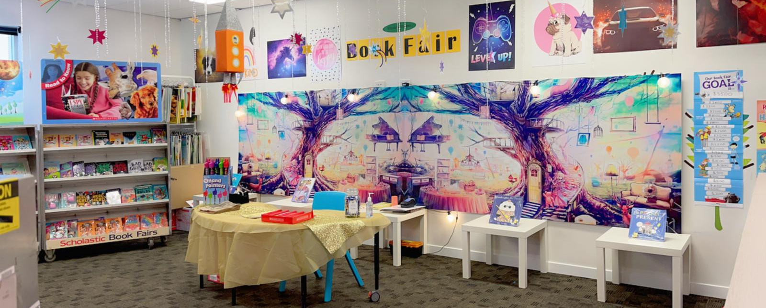

Equine Assisted Learning (EAL)

Reason to Thrive provides Equine Assisted Learning (EAL) life skill programs to children and youth who are at risk of disengagement from formal education and family.

Equine Assisted Learning (EAL) is a hand on innovative and practical way of gaining personal development and building essential life skills, with all learning-taking place in an outdoor classroom with a horse as their teacher.

Together (student and horse) learn through positive interaction and teamwork, tackling various ground-based activities (no riding) to achieve objectives with the purpose of each person learning about themselves, their strengths, their personality and the energy they give out to everyone around them.

It provides an opportunity for 10 – 18-year-olds to work alongside horses (as teachers) to build:

- Self confidence
- Self-awareness
- Communication, trust and more.
Potential outcomes.
- To develop effective commination skills
- Regulate emotional and physical behaviour
- Learn how to think outside of the box to problem solve.
- Learn to work in a team
- Develop self esteem
- Overcome barriers to change.

NAPLAN School Readiness Test (SRT)

- AIIC joined several other schools to evaluate our ability and preparedness to go online with NAPLAN testing. At AIIC, our leadership team assembled the staff and IT. department to familiarise and assess our hardware capabilities for online testing of NAPLAN commencing in 2022.
- The AIIC teaching staff and IT team have proven that AIIC is well and truly ready to transition from paper based to online NAPLAN testing.

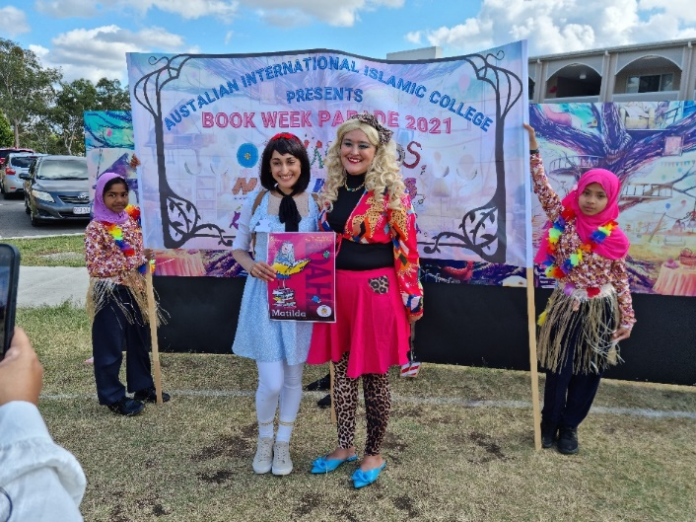
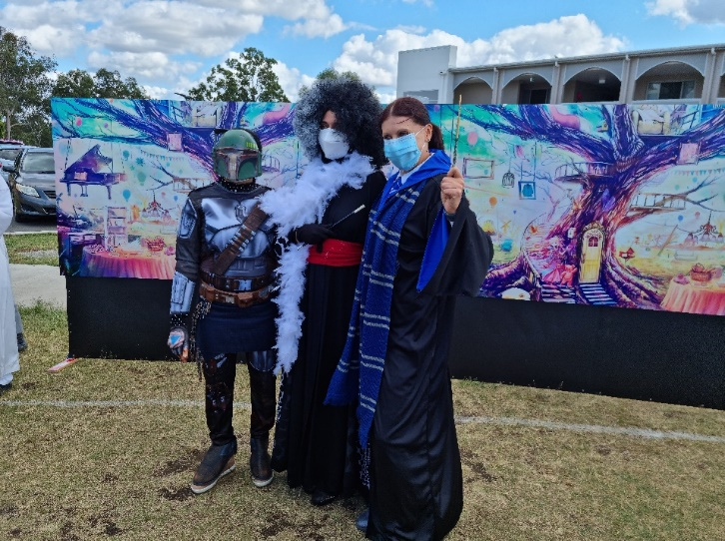

Swimming

Swimming is a key part of Physical Education. Australia is an island country with the highest number of private and public swimming pools in the world. Swimming is regarded an important life skill to be learnt by all children for their physical fitness and safety.

Despite the Sunshine State’s abundance of beaches, backyard pools, rivers and dams, Queensland is the only state in Australia that does not have compulsory or state funded swimming programs in primary schools. Swimming is a very important survival skill.

Unfortunately, many of the parents of students of AIIC who were born overseas did not get the opportunity to learn to swim. However, their children in Australia are very willing and keen to learn swimming.

The unprecedented number of drownings over the Christmas holiday period is a wakeup call for all parents to arrange swimming lessons for their children as an urgent priority.

AIIC students go to public swimming centres to learn to swim. AIIC has persuaded all swimming centres where AIIC students attend to provide students with complete privacy, not allowing any other swimmers to be in the centre when AIIC students are learning to swim.
AIC appreciates the wonderful cooperation and support of all public swimming pools who have readily complied with our request for privacy during their visits.

Brisbane Careers and Employment Expo (Tertiary Studies and Career Expo 23 March 2021)

For high school students, the Brisbane Career and Employment Expo is an excellent way to explore their post-school studies and opportunities.

The Online Career Expos this year hosted more than 120 organisations and employers with career and networking opportunities.

AIIC Year 12 students were treated to a day out at the Careers and Employment Expo held at the Brisbane Convention Centre. They actively interacted with representatives of several universities they were interested in and discussed with them their chosen courses, ATAR cut-off and choice of career opportunities.
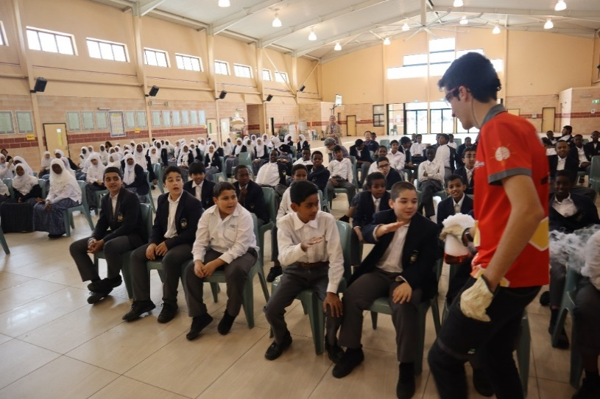
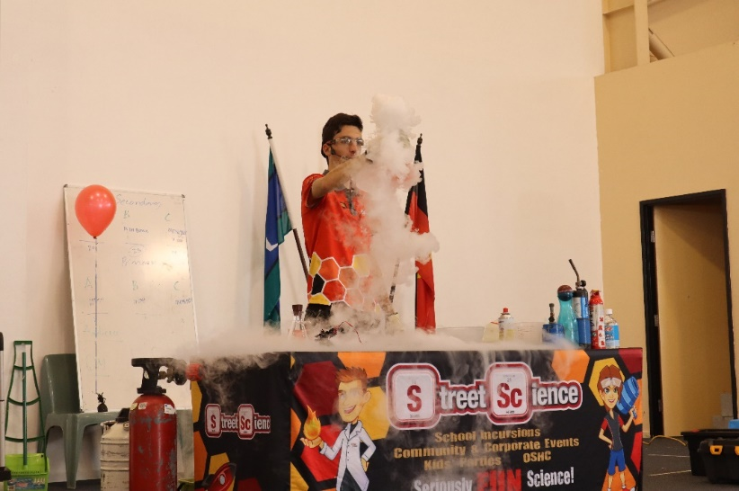

The expo was packed with truly insightful advice. Students could:
- Talk with training organisations and employers
- Gain free career advice
- Participate in various career seminars
- Learn how to write a good resume
- Discover job opportunities in the Australian Defence Force
- Test motor skills at the world skills stalls.

Attending the Career and Employment Expo opened horizons for many students, encouraging them to carefully consider and pursue several options, and providing them with the incentive to achieve even higher ATAR scores than their required cut-off. Global job opportunities are shifting towards automation based on technological advancement in digital information-based engineering. STEM studies provide students with the foundation to succeed and contribute to these new innovative industries.

Employers often look for STEM qualifications and skills which are in increasingly high demand. Currently 75% of jobs in the fastest growing industries require STEM skills.

The workforce of the future requires strong foundation skills in science and mathematics. STEM studies open the door to exciting and emerging careers where young people can use their STEM skills to solve real world problems and adapt to the changing workforce.

Visit to Translational Research Institute

AIIC Year 10 students attended Students Performing Advanced Research Queensland (SPARQ) workshop located in the Transitional Research Institute (TRI) in the premise of Princes Alexandra Hospital (P.A Hospital). TRI is dedicated to translating scientific discoveries into application for medical practice. At the STARQ laboratory, students were exposed to life experience of carrying out authentic scientific investigation in the physically contained laboratory (which is certified by the gene technology regulator) under the guidance of scientist.
Students learnt how to extract and analyse recombinant material – which is DNA technology altering genetic material outside an organism to obtain desired characteristics in the living organisms. This technology involves the insertion of DNA fragments from a variety of sources, having a desirable gene.
Scientist at ART have been conducting research to protect our environment e.g., industrial management of toxic chemicals with focus to improve environmental performance.

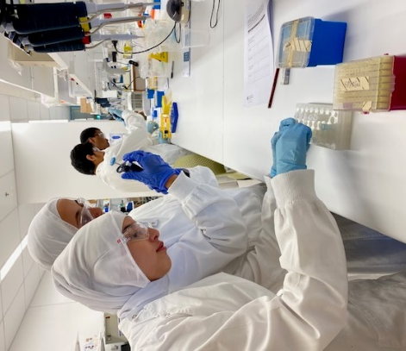
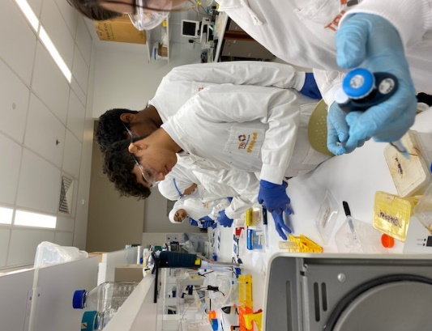
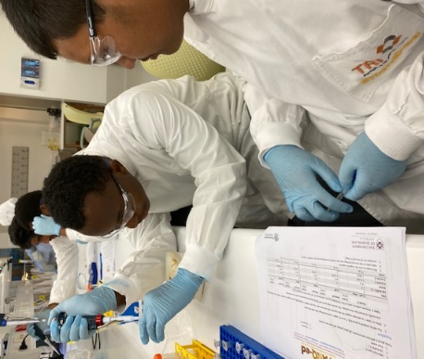

Since 1980, several valuable products like:
- Hormones
- Vaccines
- Therapeutic agenda
- Diagnostic tools
Have been developed improving health and wellbeing.

The visit to SPARQ where they performed some interesting experiments and work in very well-equipped laboratory amongst students, which created an interest in careers in science

Visit to Sir Thomas Brisbane Planetarium

The excursion to the Sir Thomas Brisbane Planetarium has proved to be one of the most enjoyable excursions for AIIC students. The Planetarium teaches general knowledge about the stars and constellation through the cosmic dome.

Cosmic Dome: The full dome immersive presentation provides a guided tour of the Brisbane sky where the astronomer points out the planets, stars and constellations visible that night.

In 2019 a new sky projection was installed. The laser-powered system generates one of the world’s brightest most detailed night sky experiences, on a 12.5 diameter projection dome.
The planetarium is well equipped with several display showings various aspects of astronomy.

Display Zone – includes two areas: the foyer and the gallery with printed exhibits, models and inter active displays on astronomy and space exploration.

Foyer Display – artefacts including:
- Fragments of asteroids
- Spacecraft models
- A replica of Neil Armstrong’s Apollo spacesuit.
The Gallery
- Depicts the Solar system
- Past star formations in the Milky Way to external galaxies.
- The Big Bang
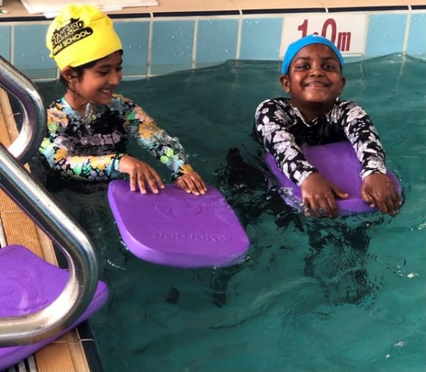

Images from Hubble Space Telescope provides detailed views of many wonders of the universe.
History of Astronomy displays – modern astronomy and modern telescopes with ancient instruments like stone circles and astrolabes.

Earth – our Blue Oasis
This new 13m gallery exhibits examines what makes earth so special for life.
It teaches factors affecting life on our planet and it’s fragility in the face of much greater forces such as solar evolution and the greater cosmic environment.

Sundial Courtyard – (Located on the eastern side of the planetarium).
The sundial courtyard features a giant concrete, steel and glass sundial which tells us the time when the sun is shining with an accuracy of 10 mins.

Street Science

Street Science provides an exciting hands-on experience designed for Prep to Year 10 in a
Terms 3 and 4 Excursion Program.
Year 6: Energy and electrical circuits
Year 4: polymers and chemistry in action

The Street Science staff provide all the gear, set up and pack up smoothly, and are always met with smiley faces and fresh excitement for some science learning.

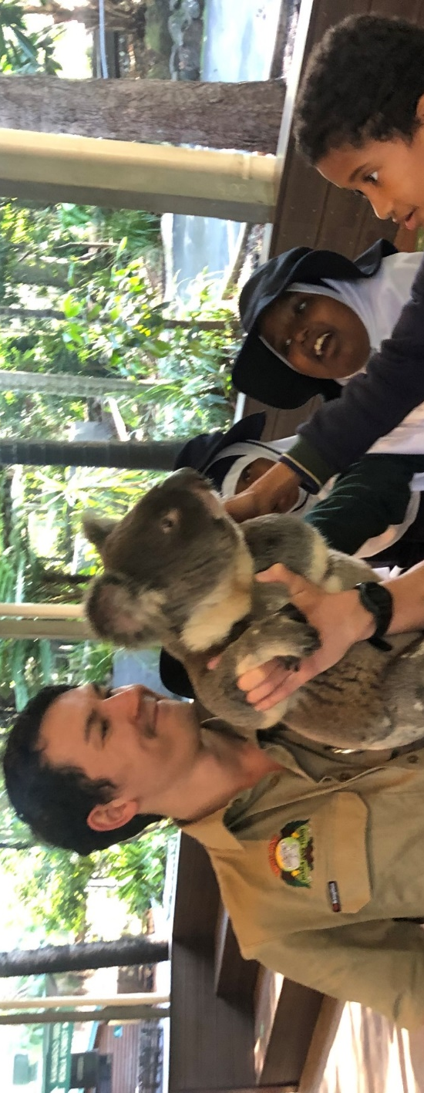
The students all enjoyed being able to experiment, play, and discover with multiple workstations to choose from. The teachers love that the students were engaged and on task for the duration of the excursion. The presenters captivated their audience and supported them throughout the whole process. Located at Unit 10, Gateway Business Centre, Nudgee Road, Banyo QLD.

Lone Pine Koala Sanctuary (World’s largest Koala Sanctuary)

The most popular excursion for primary school children is a day visit to the world’s largest Koala sanctuary, which looks after more than 100 Koalas and 70 other species of native animals.
- Birds
- Amphibians and reptiles
- Barn animals
- Wild animals

All students are given an opportunity to hold a Koala, hand-feed Kangaroos, and appreciate native Australian wildlife in a beautiful and natural setting. Visitors are free to move around and interact with many animals.

AIIC Student Attendance

The following table depicts the average attendance rate for each year level
Durack Gold Coast Buranda
Prep 89% Year 1 89% Year 2 89%
Year 3 89% Year 4 89% Year 5 89%
Year 6 90% Year 7 90% Year 8 90%
Year 9 90% Year 10 99% Year 11 91%
Year 12 91%

The highest attendance rate in 2021 was 99% for year 10 and the lowest rate of 89% was recorded for Prep students as parents are more protective of young children and often kept them home when they showed the slightest of symptoms of illness.

Management of Non-Attendance

Daily absence without notification from parents results in a text message being sent to parents to notify them of their child’s absence from school.

- Students who have been absent for long periods are provided with learning support to catch up on missed work.
- Students who are absent for a few days due to illness are given extra homework and provided with worksheets and copies of handouts.
The Teacher Aides are assigned to make sure those students are given extra support to catch up on the subject matter covered during their absence.
- For long absences (due to late return to Australia from their home countries) are students helped by a “Buddy System” where above performing students act as mentor to support them.

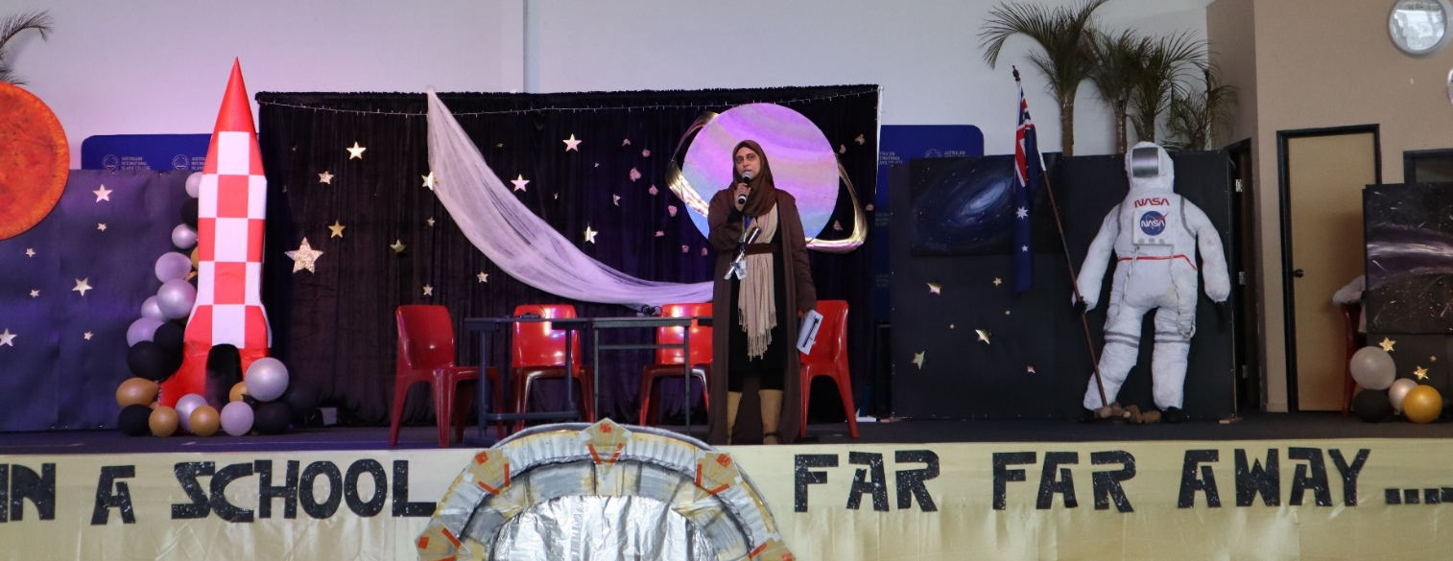

AIIC Apparent Retention Rate Year 10 to Year 12
The year 10 to 12 retention rate is defined as the number of full-time students in Year 12 in any given year expressed as the percentage of those students who were in year 10 two years previously
AIIC has recorded retention rate 86%.

Students Birthplace
Durack Campus
Durack students Country of birth percentage
Australia 58%
Eritrea 8.2%
Somalia 4.0%
Kenya 3.5%
Bangladesh 3.3%
Gold Coast Campus
Gold Coast students Country of birth percentage
Australia 81%
Kenya 2.3% Pakistan 2.0%
India 2.0%
Indonesia 1.4%
City Campus (Buranda)
City Campus students Country of birth percentage
Australia 75%
India 9%

Durack campus enrolment (90% of total enrolment)
Students born in Australia 58%
Remainder of students are born overseas, many from Africa 32%
Gold Coast campus has only 19% students who are born overseas
Hence, the gold Coast students come from established migrant families with parents who are fluent speakers of English and able to support their children in school homework.

City Campus has only 33 enrolments with similar background as the Gold Coast Campus students.

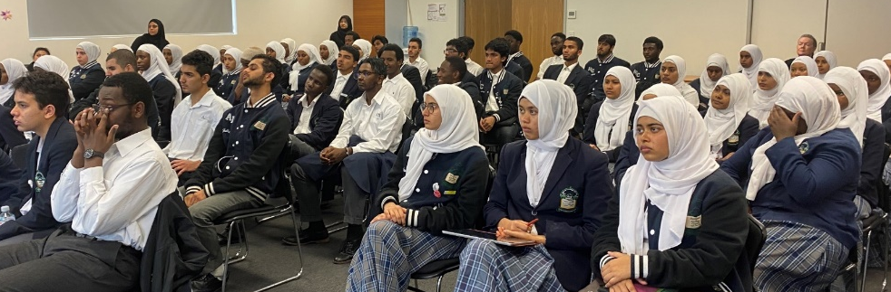

Due to the serges of Covid schools were for several weeks in remote learning mode and attendance of primary school students became a challenge.
The normal practice of taking attendance twice per day has proved difficult and recording in the TASS portal reflected lower attendance.

Looking at the percentage of students born in Australia, one may conclude that at the Gold Coast and City Campuses students enrolled are second or even third generation Australian, where the Durack students tend to be either first or second generation Australian.

AIIC Staff
AIIC employs close to 110 full time equivalent staff members across academic and administrative and service areas of its four campuses. All staff play a significant role in enabling the AIIC to deliver on its educational commitment.

AIIC values its staff for the dedicated efforts of its talented workforce. AIIC is committed to the wellbeing and safety of staff in its care.

As at December 2021, 85% of the staff at AIIC in January 2022 remained employed.

Teachers Orientation
All first-year teachers are assigned a mentor and given extra time for planning, preparation, observations and provided weekly feedback. Relief time is also allocated for collaborating work on planning and preparation of curriculum.

Professional Development
All staff are provided an opportunity to upgrade/upskill their First Aid Training by undergoing a refresher First Aid course conducted by St Johns Ambulance officers.
The four (4) Student Free days are programmed to be spent on in-house Professional Development and interactive workshops.

Each year all policies are examined. The updated policies and documented in the Staff Handbook

The college website is also regularly updated showing the current policies.
At the beginning of the year, all teachers and other key staff of the college undergo a three (3) day in-house Professional Development program ensuring all participants are fully familiar with the current policies and reporting procedures.
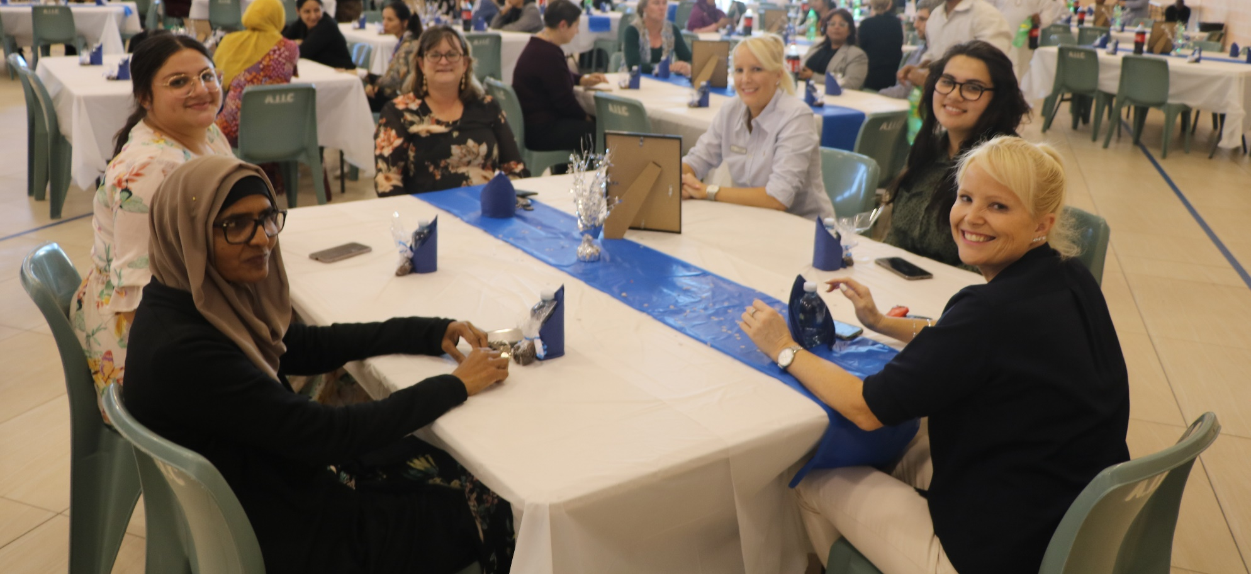

A great deal of emphasis is placed on ensuring all staff fully understand the current student protection policy, highlighting the prescribed procedure to be followed for reporting incidents.
Following is the list of key Professional Development activities attended by AIIC staff.

• ISQ School Governance for Board Members
• NIMTD - Professional Skills for the Executive Secretaries
• CENAGE: Learning Solutions for the school K-12
• 7 Steps: P.D that empowers teachers to inspire the students to improve their writing skills.
• OAMT: Queensland Association of Maths Teachers annual conference P-10 Curriculum
• Los Angeles Business Solutions
• Workplace Health and Safety- First Aid
• University of South Australia - GenforeA-Ge
• Principal's conference
• Australian Curriculum Studies Association Conference
• ACHPER - Australian Council for Health Physical Education and Recreation Conference
• Outdoor Queensland Bush Based School Best Play Nature Bush School for early year

Staff Retention

Staff retention is particularly important for the stability of the college. However, some staff are forced to leave due to changes in their spouse jobs. Some beginning teachers have after acquiring teacher registration go to outback schools to experience country life and high wages.
the staff retention is calculated by

Number of staff returned at the beginning 2021 x 100
Number of staff at the end of 2020

Eighty six percentage retention is reasonable as workforce mobility amongst beginning teachers is a fairly well known fact.

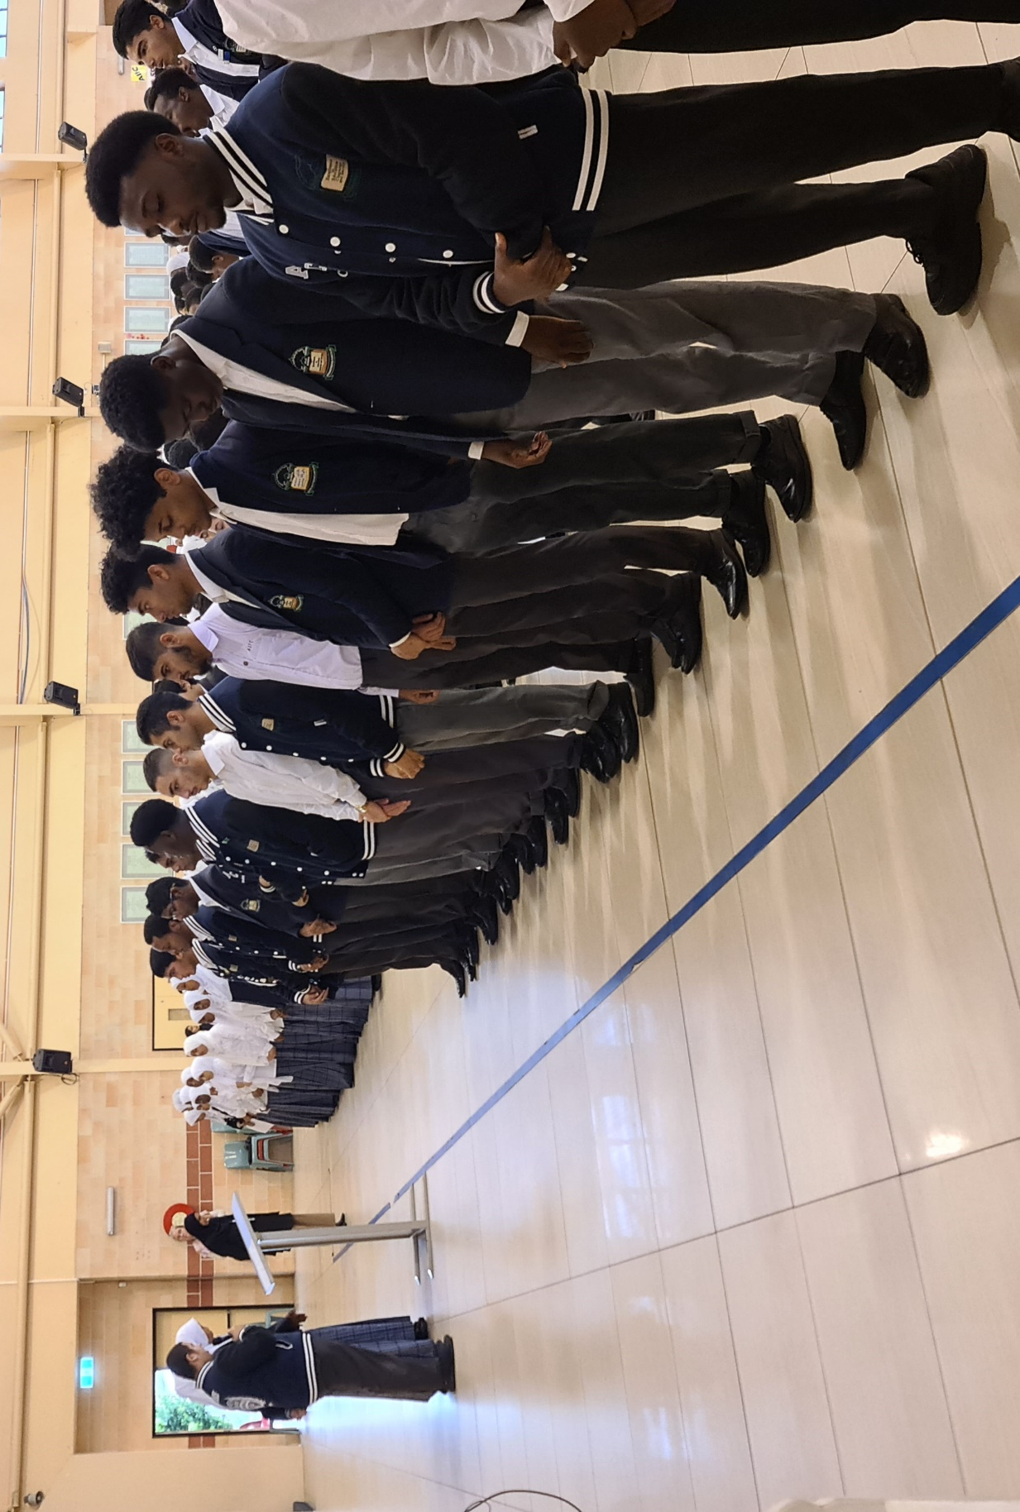

AIIC Financial Performance

The Federal government has implemented a new funding model for all independent schools called the Direct Measure of Income (DMI) funding model based on the capacity of parents to contribute to school fees determined by the median taxable income of each parent/guardian derived from the personal income tax data. Under the new funding model AIIC will sustain a material reduction in Australian Government funding in the period 2022 – 2029.

AIIC largest cost is employee expenses, which accounts for approximately 70% of cash operating costs and are underpinned by an Enterprise Bargaining Agreement. Other significant expenses include leasing, energy, insurance, and regulatory compliance costs and continue to rise at a rate well above inflation

Like all independent schools, AIIC is continually investing its profit in new infrastructure, maintenance of existing infrastructure, and reducing its debts.
A surplus in the independent school sector is considered good financial practice. It gives parents and the community confidence that AIIC is financially viable and responsibly managed

Total Income received = 19,857,663
Per students net recurrent income = 17,745

Total Capital Expenditure = 4,332,273
Government Capital Fund = 1,373,377
AIIC contribution toward Capital Works = 2,958,896
Debt paid during 2021 = 704,092

Financial sustainability depends on the college’s ability to generate sufficient operational surpluses to adequately service dept and replace depreciated assets.
AIIC has reinvested in new assets, e.g. building plant and equipment at a faster rate than their assets depreciated over the last ten year period.

The five (5) year enrolment projections are showing a growth in enrolments and also projecting reasonable surplus which are earmarked for construction of permanent classroom buildings AIIC Satellite Campuses.

The auditor examining the AIIC financial statement have provided the viability statement confirming AIIC will have sufficient funds available for its operation in 2022 onwards.

